Bug Report for website – [https://buggy.justtestit.org](https://buggy.justtestit.org/)

Prepared For Westpac

Prepared By Prabhu Lakshmanan

**Bug ID:** 27401

**Bug Name:** Navigation link is not working.

Navigation link “[Buggy Rating](https://buggy.justtestit.org/)” in home page is broken.  
**Severity:** 1-Critical  
**Priority:** 1

**Status:** New  
**Reason:** New Defect  
**Environment:** Test

**Description:**  
Navigation link “[Buggy Rating](https://buggy.justtestit.org/)” in home page is broken.

**Steps To Reproduce:**  
**1)** Login to the Application  
**2)** Click on the Navigation link “[Buggy Rating](https://buggy.justtestit.org/)”  
**3)** Nothing happens  
**4)** See the attached screenshot of the error page.

**Expected Result:** On clicking Navigation link “[Buggy Rating](https://buggy.justtestit.org/)”, should be prompted to home page successfully.

**Actual Result: Nothing happens.**

**Screenshots:**

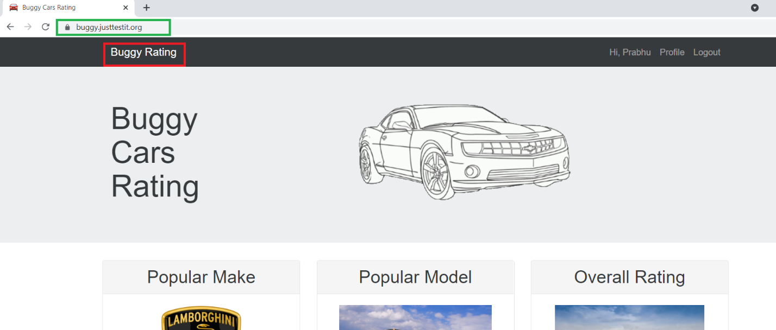

**Bug ID:** 27402

**Bug Name:** Navigation link is not working.

Navigation link “[Buggy Rating](https://buggy.justtestit.org/)” in Popular Make page is broken.  
**Severity:** 1-Critical  
**Priority:** 1

**Status:** New  
**Reason:** New Defect  
**Environment:** Test

**Description:**  
Navigation link “[Buggy Rating](https://buggy.justtestit.org/)” in “Popular Make” page is broken.

**Steps To Reproduce:**  
**1)** Login to the Application  
**2)** Click on the “Lamborghini image” under “Popular Make”

**3)** Click on the Navigation link “[Buggy Rating](https://buggy.justtestit.org/)”, to go back to the Home Page.  
**4)** Nothing happens  
**5)** See the attached screenshot of the error page.

**Expected Result:** On clicking Navigation link “[Buggy Rating](https://buggy.justtestit.org/)”, should be prompted to home page successfully.

**Actual Result: Nothing happens. when you click on the “Buggy Rating” link a URL** <https://buggy.justtestit.org/broken> **is displayed on the lower left corner.**

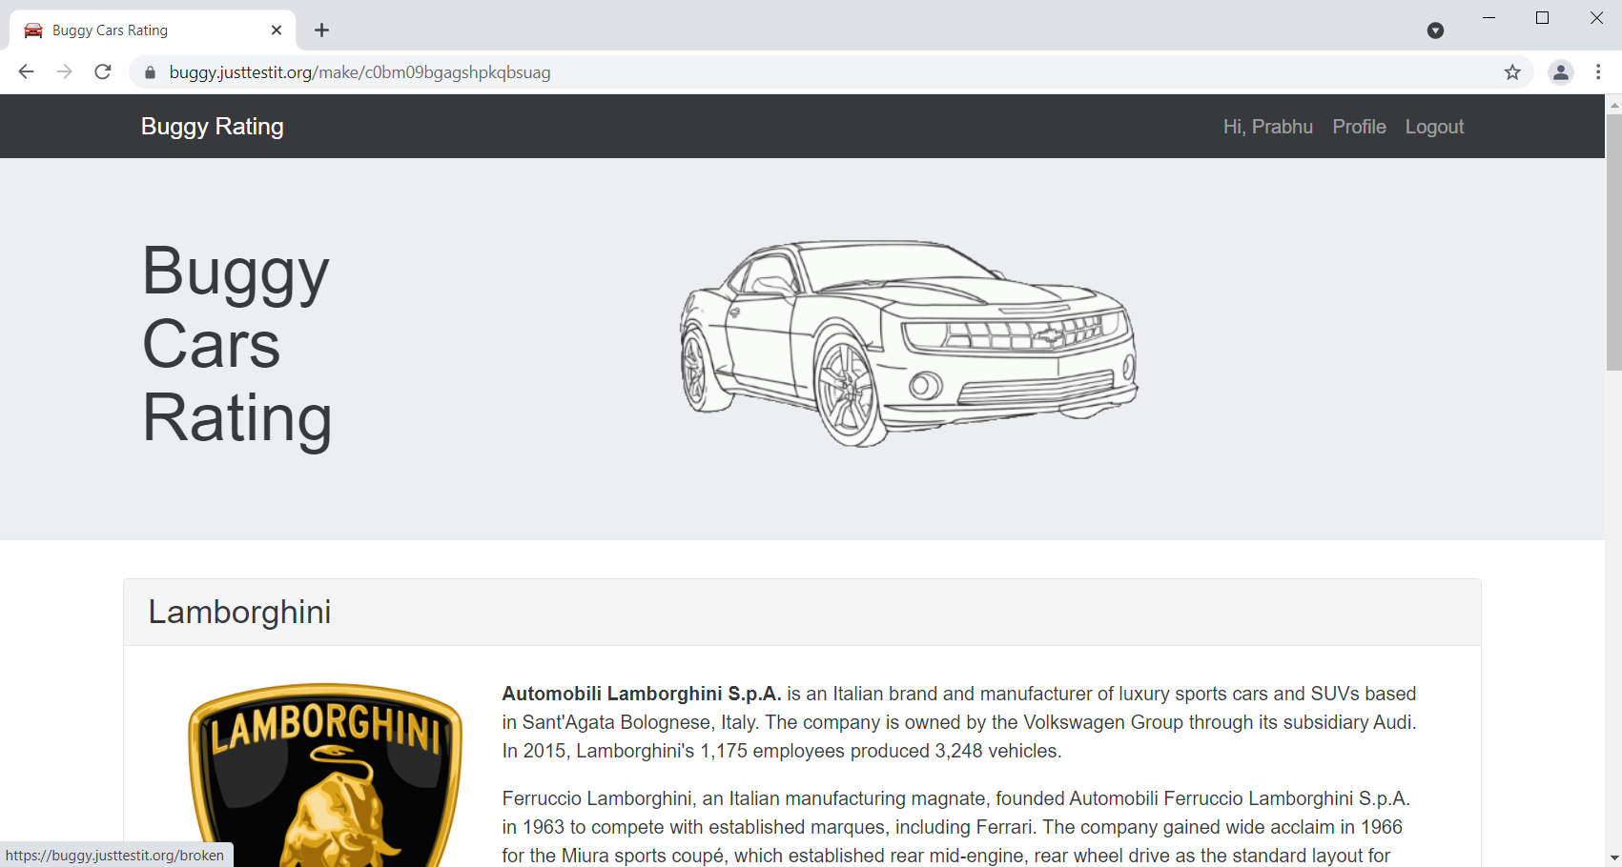

**Bug ID:** 27403

**Bug Name:** Image of the car ‘Lancia Ypsilon’ in Overall Rating page is broken.  
**Severity:** 1-Critical  
**Priority:** 1

**Status:** New  
**Reason:** New Defect  
**Environment:** Test

**Description:**  
Image of the car ‘Lancia Ypsilon’ in Overall Rating page is broken.

**Steps To Reproduce:**  
**1)** Login to the Application  
**2)** Click on the “Car’s image” under “Overall Rating”

**3)** Click “Engine” – i.e., Sort by Engine.  
**4)** It displays ‘Lancia Ypsilon’ car as the first one.  
**5)** See the attached screenshots of the error page.

**Expected Result:** Image of the car ‘Lancia Ypsilon’ should be displayed properly.

**Actual Result:** Image of the car ‘Lancia Ypsilon’ is broken.

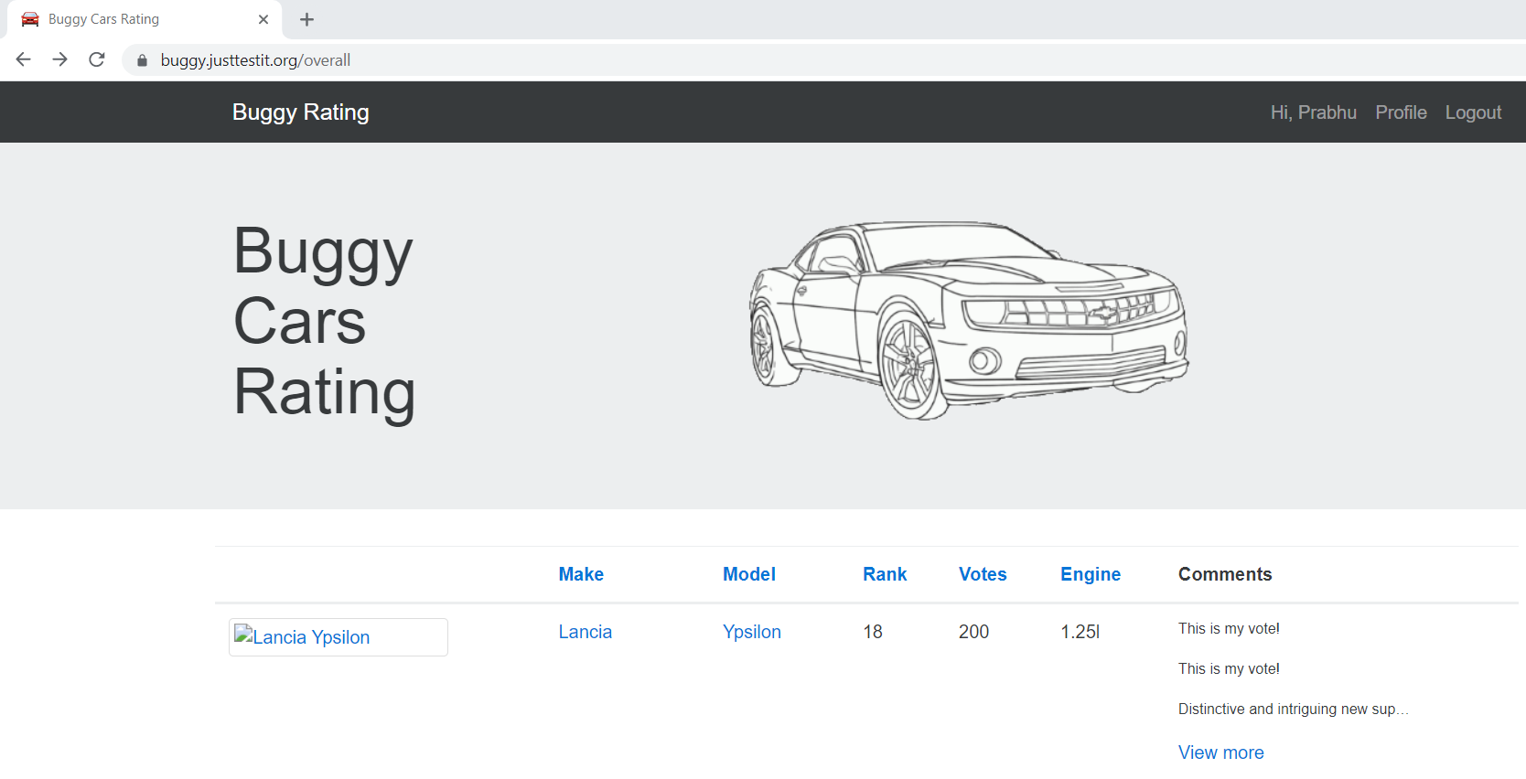

**Bug ID:** 27404

**Bug Name:** Sorting is not working.

Sorting by car “Model” and “Rank” is not working in the Popular Make page.   
**Severity:** 1-Critical  
**Priority:** 1

**Status:** New  
**Reason:** New Defect  
**Environment:** Test

**Description:**  
Sorting by car “Model” and “Rank” is not working in the Popular Make page.

**Steps To Reproduce:**  
**1)** Login to the Application  
**2)** Click on the “Lamborghini image” under “Popular Make”

**3)** Click “Model” – i.e., Sort by Model.  
**4)** Click “Rank” – i.e., Sort by Rank.  
**5)** Nothing happens

**6)** See the attached screenshots of the error page.

**Expected Result:** Cars sorted by based on Model (OR) Rank.

**Actual Result:** Nothing Happens.

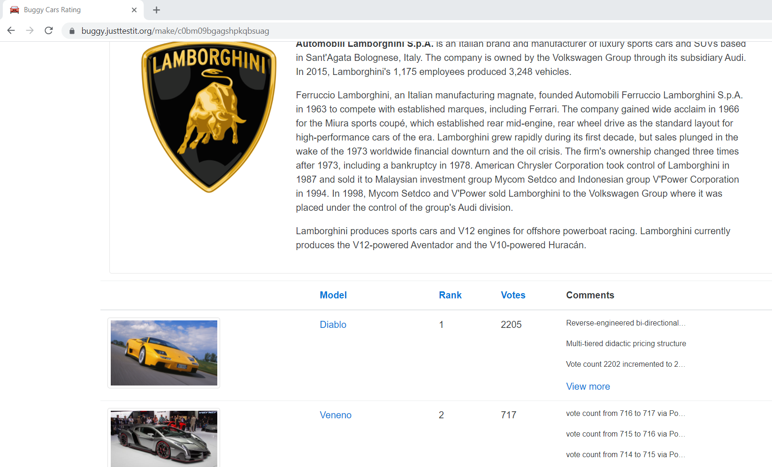

**Bug ID:** 27405

**Bug Name:** Sorting by “Vote” displays wrong order in the Popular Make page.   
**Severity:** 1-Critical  
**Priority:** 1

**Status:** New  
**Reason:** New Defect  
**Environment:** Test

**Description:**  
Sorting by “Vote” displays wrong order in the Popular Make page.

**Steps To Reproduce:**  
**1)** Login to the Application  
**2)** Click on the “Lamborghini image” under “Popular Make”

**3)** Click on “Vote” – i.e., Sort by Vote.  
**4)** Sorting done in wrong order

**5)** See the attached screenshots of the error page.

**Expected Result:** Cars should be displayed in ascending order based on Votes.

**Actual Result:** Sorting Wrongly (OR) Randomly sorting by votes.

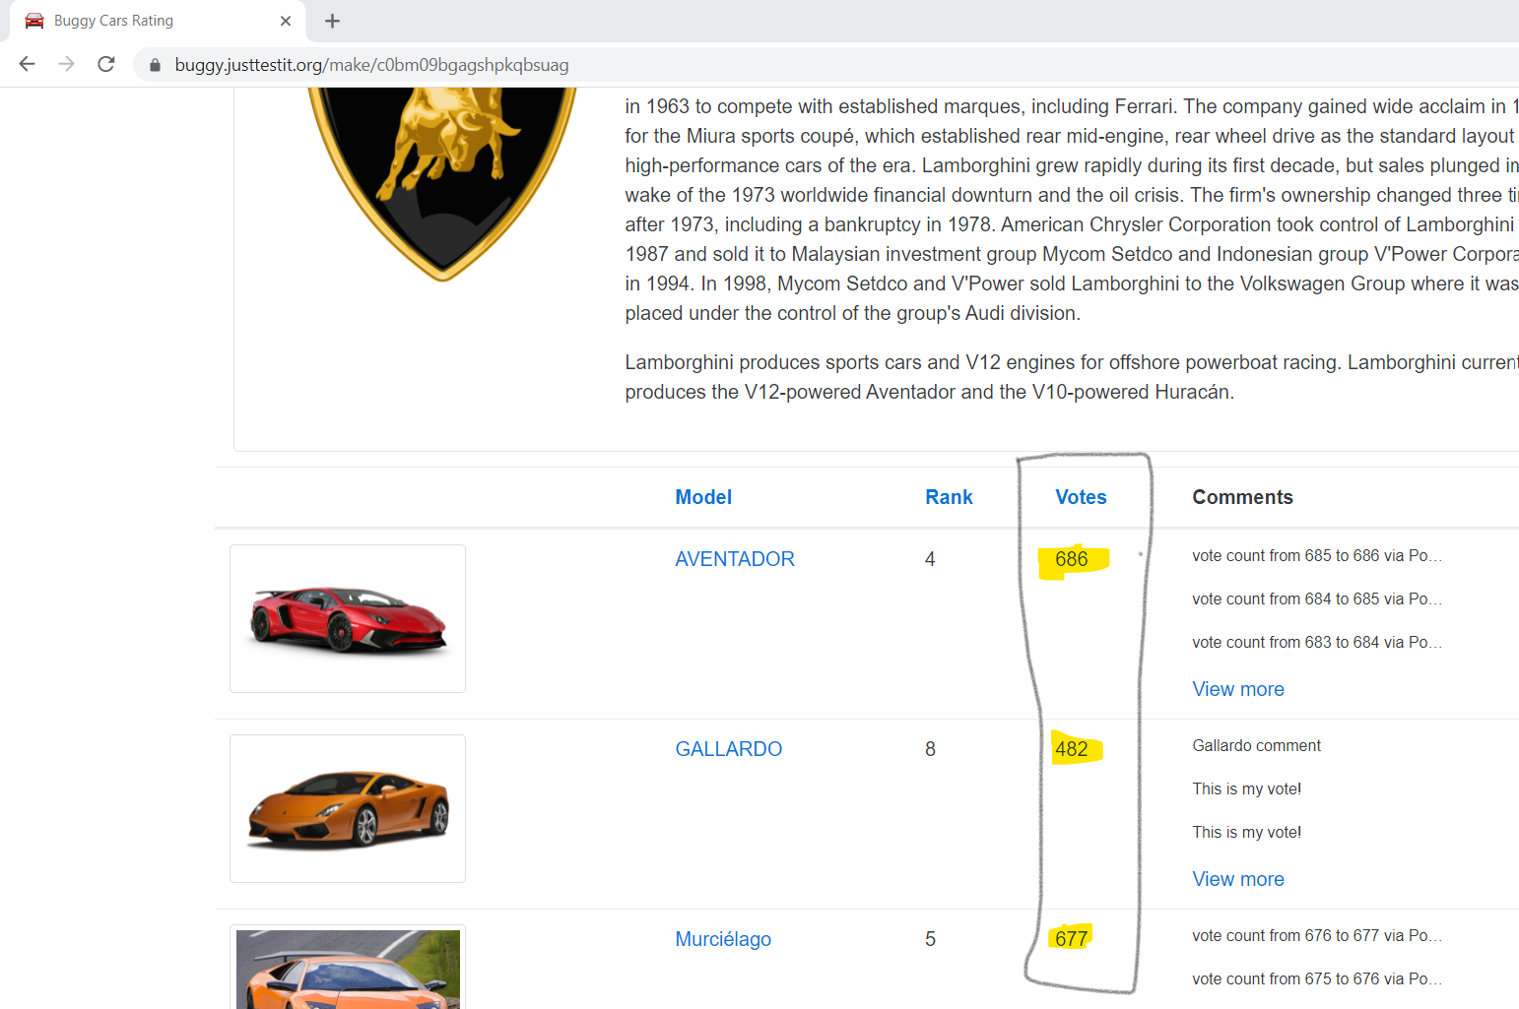

**Bug ID:** 27406

**Bug Name:** Sorting by “Rank” displays wrong order in the Overall Rating page.   
**Severity:** 1-Critical  
**Priority:** 1

**Status:** New  
**Reason:** New Defect  
**Environment:** Test

**Description:**  
Sorting by “Rank” displays wrong order in the Overall Rating page.

**Steps To Reproduce:**  
**1)** Login to the Application  
**2)** Click on the “Car’s image” under “Overall Rating”

**3)** Click on “Rank” – i.e., Sort by Rank.  
**4)** Sorting done in wrong order

**5)** See the attached screenshots of the error page.

**Expected Result:** Cars should be displayed in ascending order based on Rank.

**Actual Result:** Sorting Wrongly. i.e., 1,10,11, 13,..

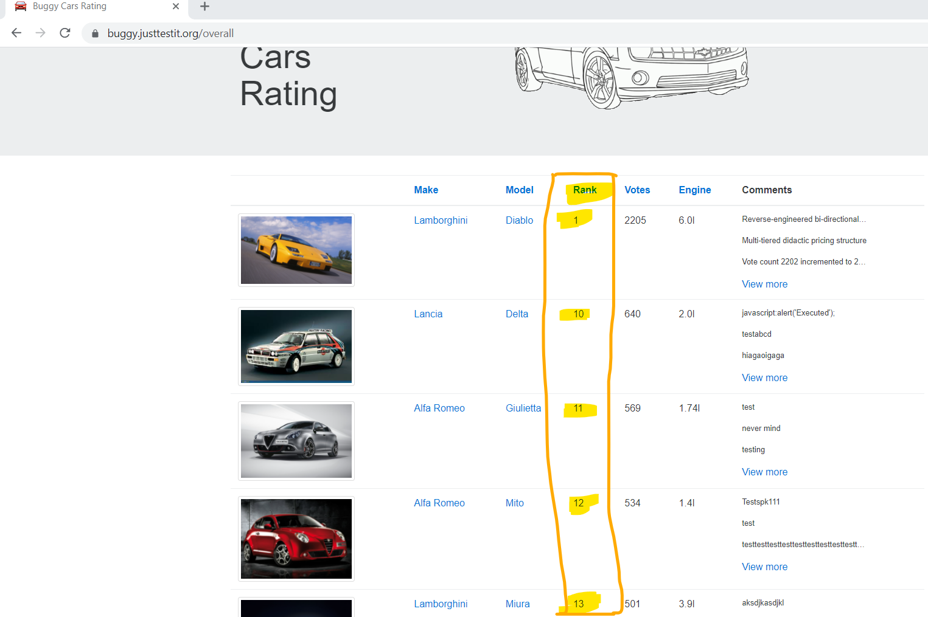

**Bug ID:** 27407

**Bug Name:** Application displays error message on clicking the SAVE button while filling a new user profile information, hence unable to create a new user in the application.  
**Severity:** 1-Critical  
**Priority:** 1

**Status:** New  
**Reason:** New Defect  
**Environment:** Test

**Description:**  
Application displays error message on clicking the SAVE button while filling a new user profile information, hence unable to create a new user in the application.

**Steps To Reproduce:**  
**1)** Login to the Application  
**2)** Navigate to the “Profile”

**3)** Fill all the user information fields.  
**4)** Select Hobby as “Knitting”

**5)** Click on the ‘Save’ button

**6)** Displays error message **“Unknown error”**

**7)** See the attached screenshots of the error page.

**Expected Result:** On clicking SAVE button, it should display a success message “**The profile has been saved successful**”.

**Actual Result:** Displays error message **“Unknown error”**

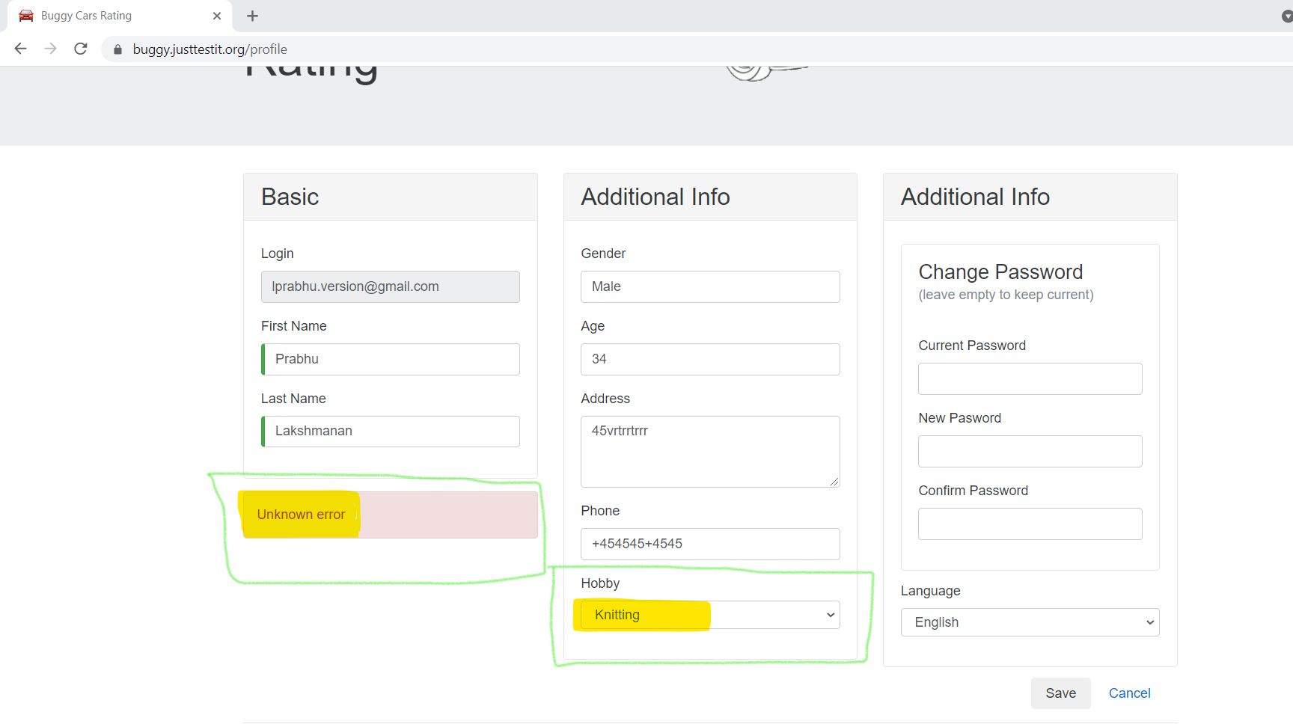

**Bug ID:** 27408

**Bug Name:** After clicking logout button, it still displays the user profile information screen.  
**Severity:** 2-High  
**Priority:** 3

**Status:** New  
**Reason:** New Defect  
**Environment:** Test

**Description:**  
After clicking logout button, it still displays the user profile information screen.

**Steps To Reproduce: Scenario 1:**  
**1)** Login to the Application  
**2)** Navigate to the “Profile”

**3)** Fill all the user information fields.  
**4)** Click on the ‘Save’ button

**5)** Click “Logout”

**6)** It still displays the profile information screen.

**7)** See the attached screenshots of the error page.

**Steps To Reproduce: Scenario 2:**  
**1)** Login to the Application  
**2)** Navigate to the “Profile”

**3)** Click “Logout”

**4)** It still displays the profile information screen.

**5)** See the attached screenshots of the error page.

**Expected Result:** On clicking logout button, it should display the Home Page.

**Actual Result:** It still displays the profile information screen.

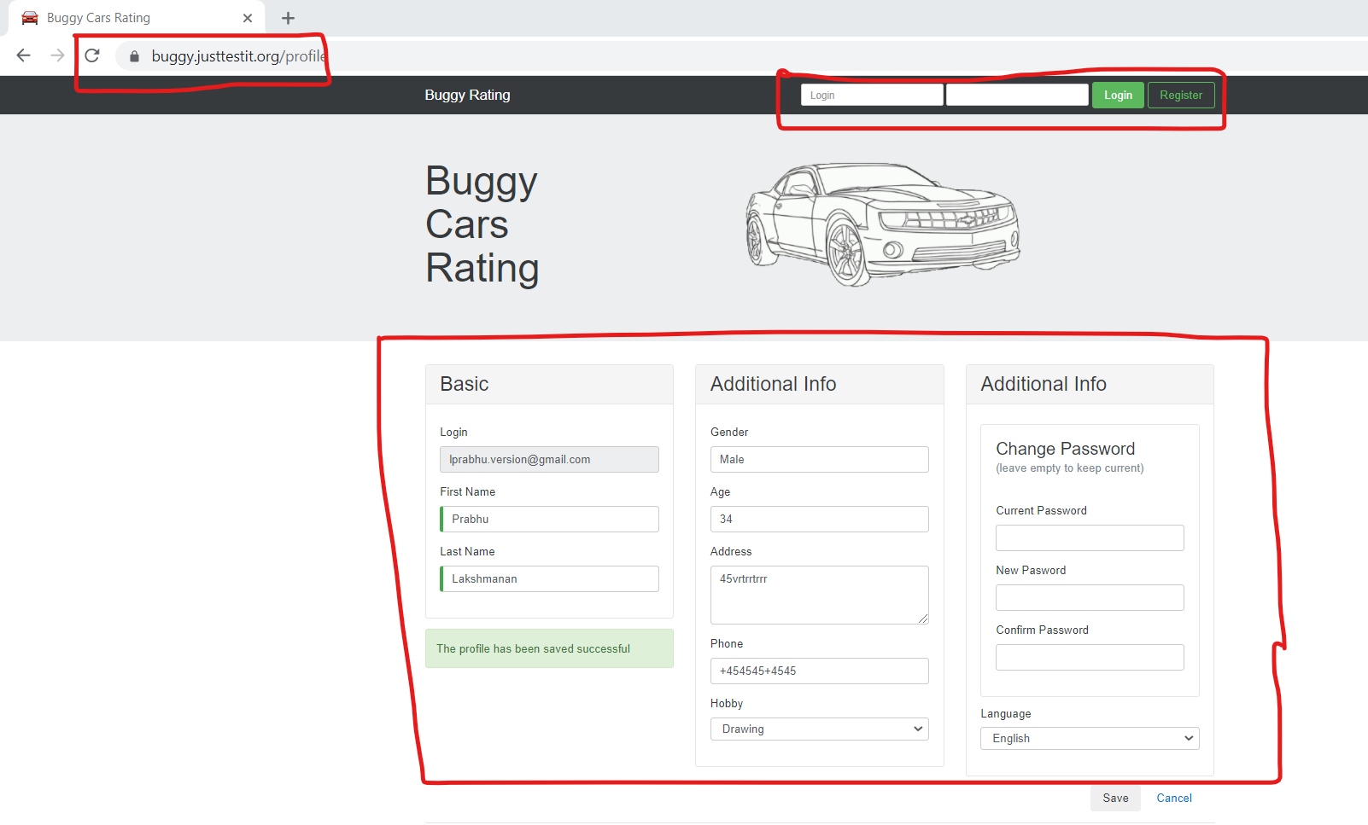

**Bug ID:** 27409

**Bug Name:** Field Validation is missing for the Age Field.  
**Severity:** 3-Medium  
**Priority:** 3

**Status:** New  
**Reason:** New Defect  
**Environment:** Test

**Description:**  
Field Validation is missing for the Age Field.

**Steps To Reproduce:**  
**1)** Login to the Application  
**2)** Navigate to the “Profile”

**3)** Fill the age field with Alpha Numeric values.  
**4)** See the attached screenshots of the error page.

**Expected Result:** It should not allow the user to enter alphabets in the Age field.

**Actual Result:** It allows the user to enter alphabets in the Age field.

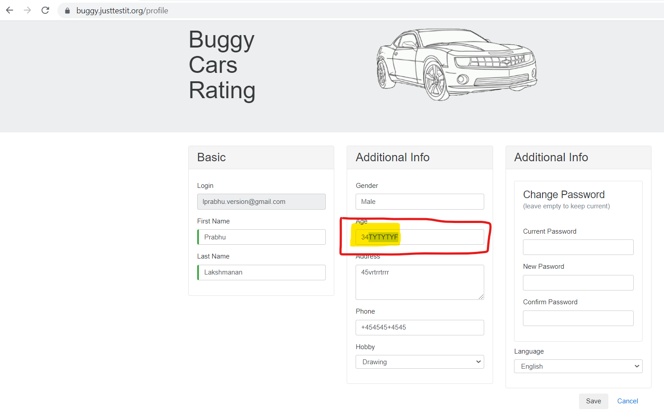

**Bug ID:** 27410

**Bug Name:** Field Validation is missing for the Phone Number Field.  
**Severity:** 3-Medium  
**Priority:** 3

**Status:** New  
**Reason:** New Defect  
**Environment:** Test

**Description:**  
Field Validation is missing for the Phone Number Field.

**Steps To Reproduce:**  
**1)** Login to the Application  
**2)** Navigate to the “Profile”

**3)** Fill the phone number field with multiple “+” symbol.  
**4)** See the attached screenshots of the error page.

**Expected Result:** It should not allow the user to enter multiple “+” symbol in the phone field.

**Actual Result:** It allows the user to enter multiple “+” symbol in the phone field.

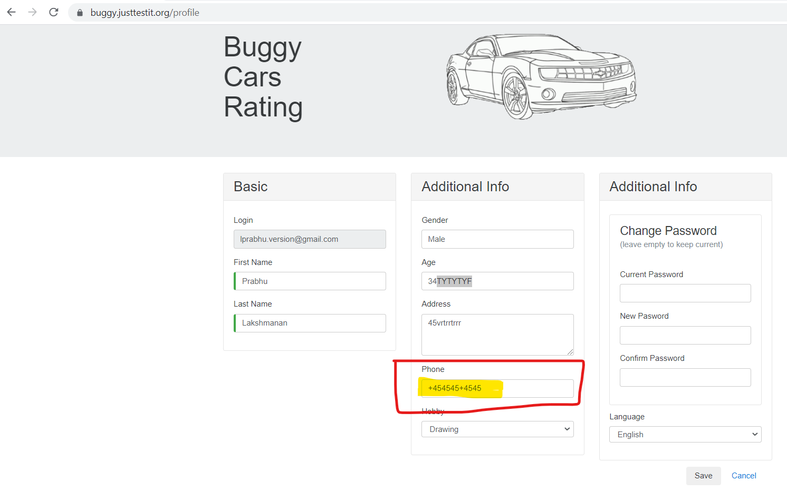

**Bug ID:** 27411

**Bug Name:** “Go Back” functionality is not working in Popular Make page.  
**Severity:** 3-Medium  
**Priority:** 3

**Status:** New  
**Reason:** New Defect  
**Environment:** Test

**Description:**  
“Go Back” functionality is not working in Popular Make page.

**Steps To Reproduce:**  
**1)** Login to the Application  
**2)** Click on the “Lamborghini image” under “Popular Make”

**3)** Click Next page i.e., Go to Page No.2  
**4)** Click “Go Back” button.  
**5)** See the attached screenshot of the error page.

**Expected Result:** On clicking on the “Go Back” button, it should be prompted to previous page successfully i.e., Page No.1

**Actual Result:** When you click on the “Go Back” button, it is going to the “Home Page”.

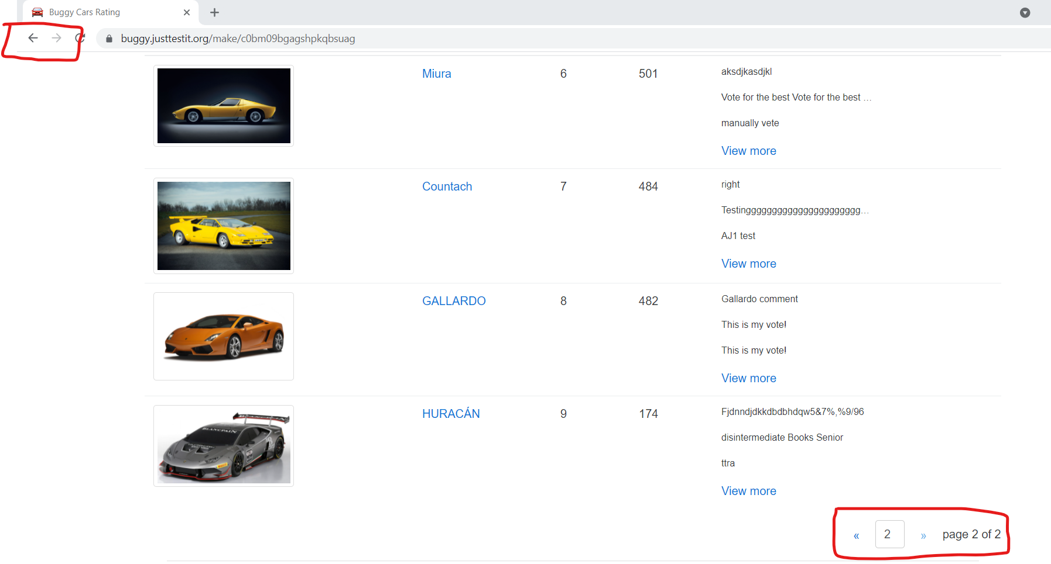

**Bug ID:** 27412

**Bug Name:** “Go Back” functionality is not working in Overall Rating page.  
**Severity:** 3-Medium  
**Priority:** 3

**Status:** New  
**Reason:** New Defect  
**Environment:** Test

**Description:**  
“Go Back” functionality is not working in Overall Rating page.

**Steps To Reproduce:**  
**1)** Login to the Application  
**2)** Click on the “Car’s image” under “Overall Rating”

**3)** Click Next page i.e., either Go to Page No.2 / 3 / 4 / 5  
**4)** Click “Go Back” button.  
**5)** See the attached screenshot of the error page.

**Expected Result:** On clicking on the “Go Back” button, it should be prompted to previous page successfully.

**Actual Result:** When you click on the “Go Back” button, it is going to the “Home Page”.

